

# 

### Semester Two Examination, 2019

### Question/Answer booklet

# MATHEMATICS

**APPLICATIONS**

**UNITS 3 AND 4**

## Section Two:

## Calculator-assumed

Your name : _________________________________

## Time allowed for this section

Reading time before commencing work: ten minutes

Working time: one hundred minutes

## Materials required/recommended for this section

***To be provided by the supervisor***

This Question/Answer booklet

Formula sheet (retained from Section One)

***To be provided by the candidate***

Standard items: pens (blue/black preferred), pencils (including coloured), sharpener,  
correction fluid/tape, eraser, ruler, highlighters

Special items: drawing instruments, templates, notes on two unfolded sheets of A4 paper, and up to three calculators approved for use in this examination

## Important note to candidates

No other items may be taken into the examination room. It is **your** responsibility to ensure that you do not have any unauthorised material. If you have any unauthorised material with you, hand it to the supervisor **before** reading any further.

## Structure of this paper

|  |  |  |  |  |  |
| --- | --- | --- | --- | --- | --- |
| Section | Number of questions available | Number of questions to be answered | Working  time (minutes) | Marks available | Percentage of examination |
| Section One:  Calculator-free | 8 | 8 | 50 | 52 | 35 |
| Section Two:  Calculator-assumed | 13 | 13 | 100 | 98 | 65 |
|  | | |  | **Total** | 100 |

|  |  |  |
| --- | --- | --- |
| Markers use only | | |
| Question | Maximum | Mark |
| 9 | 6 |  |
| 10 | 6 |  |
| 11 | 11 |  |
| 12 | 6 |  |
| 13 | 6 |  |
| 14 | 5 |  |
| 15 | 8 |  |
| 16 | 6 |  |
| 17 | 8 |  |
| 18 | 9 |  |
| 19 | 7 |  |
| 20 | 10 |  |
| 21 | 10 |  |
| S2 Total | 98 |  |
| S2 Wt (×0.6633) | 65% |  |

## Instructions to candidates

1. The rules for the conduct of examinations are detailed in the school handbook. Sitting this examination implies that you agree to abide by these rules.

2. Write your answers in this Question/Answer booklet preferably using a blue/black pen.  
Do not use erasable or gel pens.

3. You must be careful to confine your answer to the specific question asked and to follow any instructions that are specified to a particular question.

4. Show all your working clearly. Your working should be in sufficient detail to allow your answers to be checked readily and for marks to be awarded for reasoning. Incorrect answers given without supporting reasoning cannot be allocated any marks. For any question or part question worth more than two marks, valid working or justification is required to receive full marks. If you repeat any question, ensure that you cancel the answer you do not wish to have marked.

5. It is recommended that you do not use pencil, except in diagrams.

6. Supplementary pages for planning/continuing your answers to questions are provided at the end of this Question/Answer booklet. If you use these pages to continue an answer, indicate at the original answer where the answer is continued, i.e. give the page number.

7. The Formula sheet is not to be handed in with your Question/Answer booklet.

Section Two: Calculator-assumed 65% (98 Marks)

This section has**thirteen (****13)** questions. Answer **all** questions. Write your answers in the spaces provided.

Working time: 100 minutes.

Question 9 (6 marks)

(a) Connected planar graph $G_{1}$ has $18$ faces and $25$ edges. Determine the number of vertices $G_{1}$ has. (2 marks)

(b) Draw graph $G_{2}$ so that it has $6$ vertices, is a tree and is not semi-Eulerian. (2 marks)

(c) Graph $G_{3}$ is shown below. Redraw $G_{3}$ to clearly show that it is bipartite, underlining vertex $A$ and the other vertices that belong to its group. (2 marks)

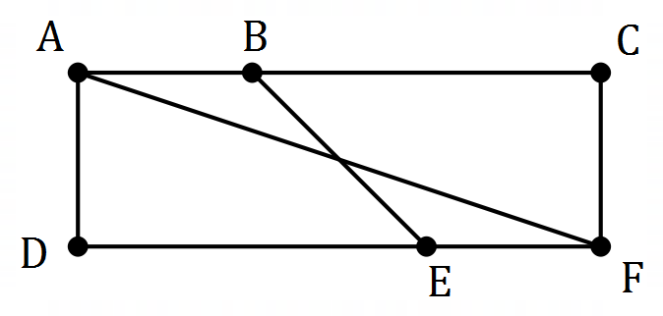

Question 10 (6 marks)

The number of tickets $T_{n}$ remaining for a musical event at the start of day $n$ can be modelled by the recursive rule $T_{n+1}=T_{n}-17$. At the start of day $1$, there were $646$ tickets remaining.

(a) Complete the table below. (2 marks)

|  |  |  |  |  |
| --- | --- | --- | --- | --- |
| $$n$$ | $$5$$ | $$10$$ | $$15$$ | $$20$$ |
| $$T_{n}$$ |  |  |  |  |

(b) Would the graph of $T_{n}$ against $n$ appear to be linear or non-linear? (1 mark)

(c) The th term rule for this sequence is $T_{n}=b+an$. Determine the value of the constant $a$ and the value of the constant $b$. (2 marks)

(d) At the start of day $k$, fewer than $50$ tickets remain. State the value of $k$. (1 mark)

Question 11 (11 marks)

The scatterplot and table below show the length ($L$) and the weight ($W$) of some mackerel, a species of fish.

|  |  |  |  |  |  |  |  |  |  |  |  |  |
| --- | --- | --- | --- | --- | --- | --- | --- | --- | --- | --- | --- | --- |
| $L$ (cm) | $$25$$ | $$32$$ | $$39$$ | $$30$$ | $$42$$ | $$28$$ | $$35$$ | $$44$$ | $$33$$ | $$36$$ | $$27$$ | $$38$$ |
| $W$ (kg) | $$0.21$$ | $$0.39$$ | $$0.77$$ | $$0.41$$ | $$0.83$$ | $$0.38$$ | $$0.55$$ | $$0.85$$ | $$0.52$$ | $$0.62$$ | $$0.25$$ | $$0.58$$ |

(a) By viewing a scatterplot of this data on your calculator, identify and describe the direction and form of the relationship between the variables. (2 marks)

(b) Calculate the correlation coefficient between the variables and use it to describe the strength of their association. (2 marks)

(c) What percentage of the variation in weight can be explained by the variation in the length for this sample? (1 mark)

(d) Using length as the explanatory variable, determine the equation of the least-squares line to model the linear relationship between the variables. (2 marks)

(e) What increase in weight can be expected for each additional centimetre in length for these mackerel? (1 mark)

(f) Another mackerel in the sample had a length of $41$ cm. Predict the weight of this fish and comment on two factors that support the reliability of this prediction. (3 marks)

Question 12 (6 marks)

An investor is considering placing the sum of $\$75 000$ into one of three investments for $2$ years.

Investment A offers a return of $7.65\%$ compounded quarterly.

(a) Determine the profit that the investor would achieve through investment A. (2 marks)

Investment B offers a return of $7.58\%$ compounded daily.

(b) Calculate the difference in profit that the investor would achieve through investment B compared to investment A. (2 marks)

Investment C offers a return of $7.6\%$ compounded monthly.

(c) Rank the three investments in order, from highest to lowest profit. Justify your answer.

(2 marks)

Question 13 (6 marks)

A random sample of $450$ TAFE students studying the same diploma was taken. Their study mode and enjoyment of the course is summarised in the table below.

|  |  |  |  |
| --- | --- | --- | --- |
|  | | Study mode | |
| Attend campus | Online |
| Level of course enjoyment | High | $$114$$ | $$45$$ |
| Moderate | $$140$$ | $$52$$ |
| Low | $$55$$ | $$23$$ |
| None | $$16$$ | $$5$$ |

(a) Show that the study mode of approximately $72\%$ of the students in the sample is to attend campus. (2 marks)

(b) Complete the two-way frequency table below to show the column percentages for the above data, rounding to the nearest whole number. (2 marks)

|  |  |  |  |
| --- | --- | --- | --- |
|  | | Study mode | |
| Attend campus | Online |
| Level of course enjoyment | High |  |  |
| Moderate |  |  |
| Low |  |  |
| None |  |  |

(c) Explain whether the data suggests the presence of an association between the variables.

(2 marks)

Question 14 (5 marks)

A young person has a bank account that pays no interest. At the start of each week they withdraw a fixed percentage of the balance to spend and then deposit a lump sum from their wages. The balance of the account at the end of week $n$ is given by $A_{n}$, where

$$A_{n+1}=0.92A_{n}+28, A_{1}=74.92.$$

(a) Calculate $A_{5}$ and explain what this figure represents.

(2 marks)

(b) State what percentage of the balance they withdraw each week. (1 mark)

(c) The young person plans to continue operating the account in this manner until it holds at least $\$500$. Comment on this plan. (2 marks)

Question 15 (8 marks)

A delivery driver must leave depot $D$ at $8:30$ am, deliver packages to three schools ($A$, $B$ and $C$) and then return to the depot. The table below shows the travel times between the various locations in minutes.

|  |  |  |  |
| --- | --- | --- | --- |
|  | $$A$$ | $$B$$ | $$C$$ |
| $$D$$ | $$21$$ | $$22$$ | $$24$$ |
| $$C$$ | $$23$$ | $$26$$ |  |
| $$B$$ | $$25$$ |  |  |

(a) Construct a weighted graph to represent this information. (3 marks)

(b) Explain why the graph in part (a) is a complete graph. (2 marks)

(c) Determine the route the driver should take to minimise delivery time and calculate the time they will arrive back at the depot if they spend $7$ minutes at each school handing over the packages. (3 marks)

Question 16 (6 marks)

An electric kiln is switched on and after $n$ minutes, the temperature of the kiln $T_{n}$ is given by the recursive rule $T_{n+1}=1.35T_{n}$. The initial temperature of the kiln, $T_{0}$, is $25°C$.

(a) Calculate the temperature of the kiln after $1$ minute. (1 mark)

(b) Graph the temperature of the kiln for $n=0, 1, 2, 3, 4, 5$ and $6$ on the axes below. (3 marks)

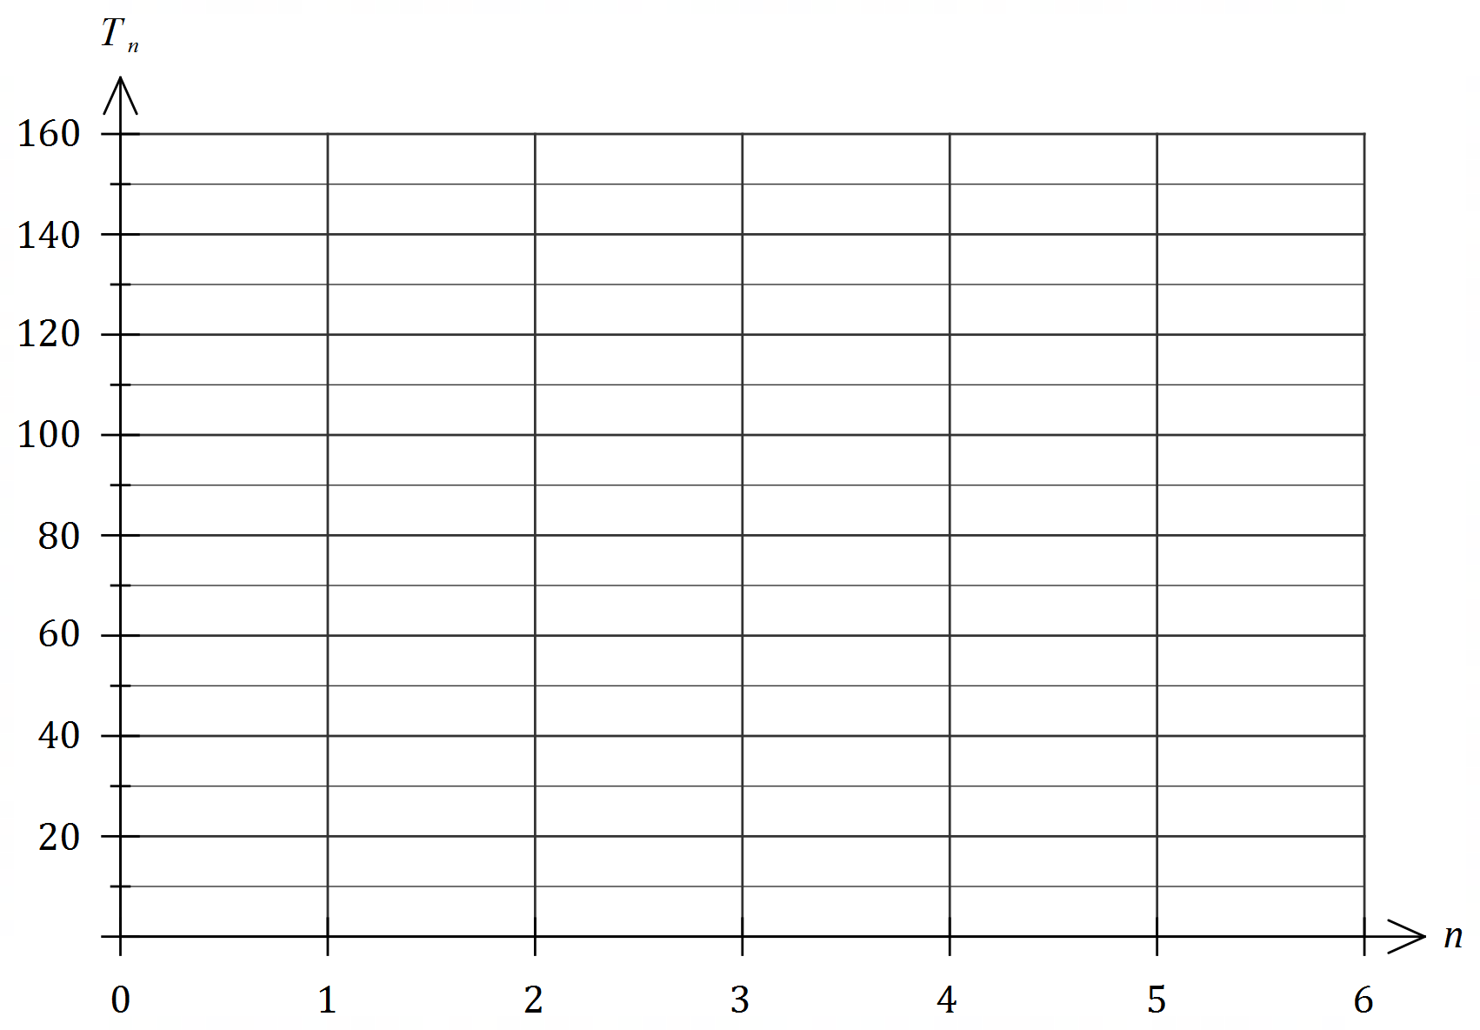

(c) Name the type of growth displayed in the graph. (1 mark)

(d) During which minute does the temperature of the kiln first increase by more than $200°C$?

(1 mark)

Question 17 (8 marks)

A customer in a store is offered a reducible interest loan that attracts interest of $8.4\%$ compounded monthly to purchase a $\$2 545.39$ computer and accessories. The monthly loan repayment is $\$151$.

The customer set up the spreadsheet below to analyse the loan, rounding the displayed figures to the nearest cent.

|  |  |  |  |  |
| --- | --- | --- | --- | --- |
| Month | Balance at start of month ($) | Interest for month | Repayment | Balance at end of month ($) |
| $$1$$ | $$2 545.39$$ | $$17.82$$ | $$151.00$$ | $$2 412.21$$ |
| $$2$$ | $$2 412.21$$ | $$16.89$$ | $$151.00$$ | $$2 278.09$$ |
| $$3$$ |  |  |  |  |

(a) Complete row $3$ of the spreadsheet. (3 marks)

(b) Determine a simplified recurrence relation for $B_{n}$, the loan balance at the start of month $n$.

(2 marks)

(c) State the number of repayments required to pay off the loan. (1 mark)

(d) Determine the total amount of interest paid over the life of the loan. (2 marks)

Question 18 (9 marks)

An experiment involved measuring the voltage $v$ in a circuit after $t$ seconds. The equation of the least-squares line to model the linear relationship between $v$ and $t$ is given by $v=5.54-0.31t$ and $r_{vt}=-0.935$.

The residual plot for the linear model is shown below.

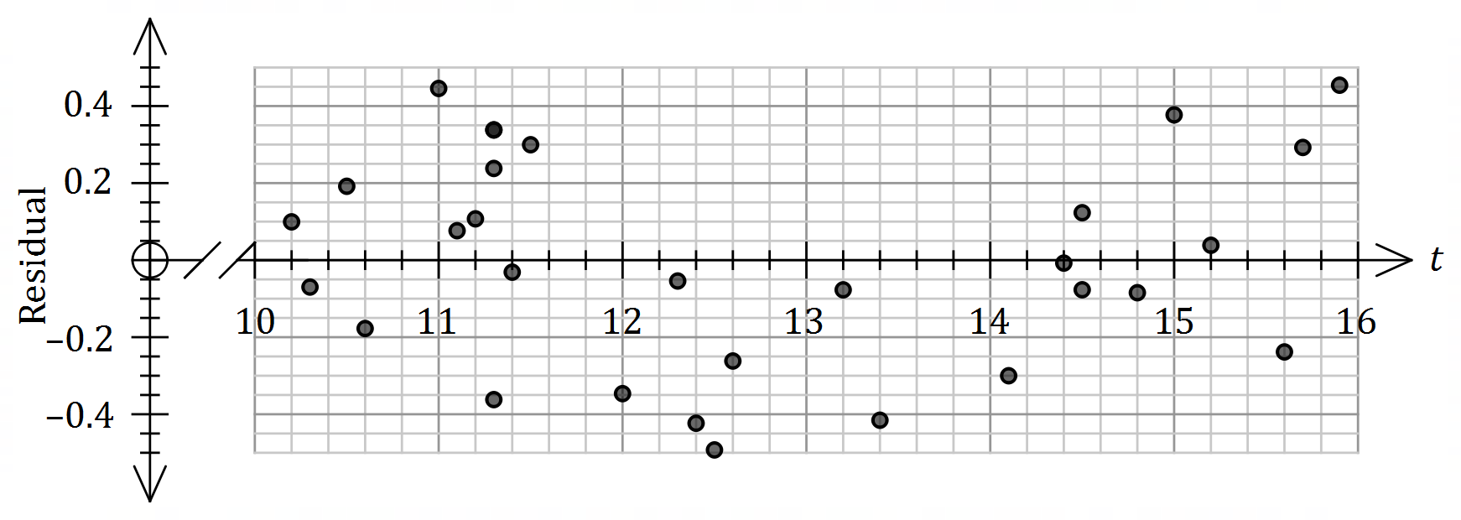

(a) After $10.4$ seconds, the measured voltage was $2.72$. Calculate the residual for this point and add it to the plot above. (3 marks)

(b) Explain what information in this question

(i) supports the use of the linear model. (2 marks)

(ii) does not support the use of the linear model. (2 marks)

(c) The residual for the voltage measured after $12$ seconds is shown on the plot above. Determine what voltage was measured at this time. (2 marks)

Question 19 (7 marks)

An annuity compounds interest annually and its value after $n$ withdrawals can be modelled using the recurrence relation

$$T_{n+1}=1.054T_{n}-37 500, T_{0}=478 000.$$

(a) Use the relation to state

(i) the annual percentage interest rate. (1 mark)

(ii) the initial value of the annuity. (1 mark)

(b) Calculate the balance of the annuity, to the nearest dollar, after $4$ withdrawals. (1 mark)

(c) The annuity is closed after $15$ withdrawals. Calculate the total interest paid by the annuity up to this time. (2 marks)

(d) From the outset, the annual withdrawal can be reduced so that the annuity becomes a perpetuity. Briefly explain what a perpetuity is and determine the withdrawal required.

(2 marks)

Question 20 (10 marks)

The number of people ($n$, in thousands) studying in Australia with a student visa from $2015$ to $2017$ are shown in the graph and table below.

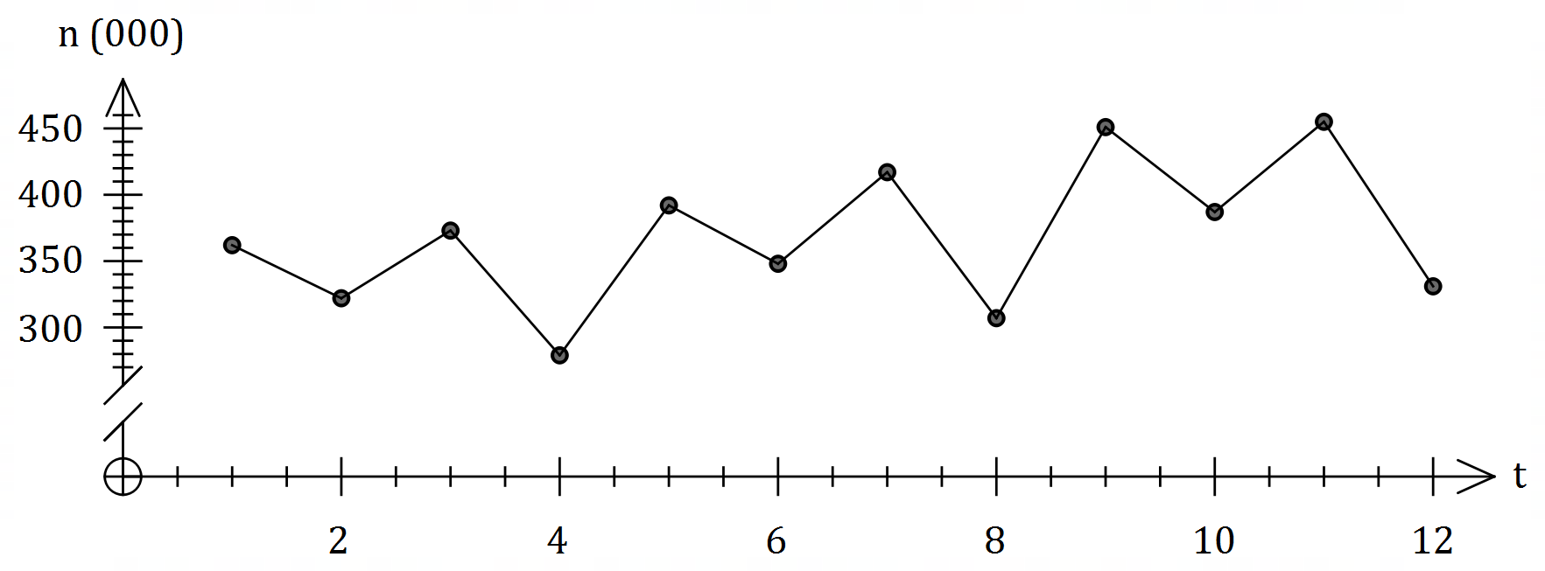

|  |  |  |  |  |  |
| --- | --- | --- | --- | --- | --- |
| Year | Quarter | Time ($t$) | Number ( $n$ $000$'s) | Quarterly mean | Percentage of quarterly mean |
| $$2015$$ | $$1$$ | $$1$$ | $$362$$ | $$A$$ | $$108.4$$ |
| $$2$$ | $$2$$ | $$322$$ | $$96.4$$ |
| $$3$$ | $$3$$ | $$373$$ | $$111.7$$ |
| $$4$$ | $$4$$ | $$279$$ | $$83.5$$ |
| $$2016$$ | $$1$$ | $$5$$ | $$392$$ | $$366$$ | $$B$$ |
| $$2$$ | $$6$$ | $$348$$ | $$95.1$$ |
| $$3$$ | $$7$$ | $$417$$ | $$113.9$$ |
| $$4$$ | $$8$$ | $$307$$ | $$83.9$$ |
| $$2017$$ | $$1$$ | $$9$$ | $$451$$ | $$406$$ | $$111.1$$ |
| $$2$$ | $$10$$ | $$387$$ | $$95.3$$ |
| $$3$$ | $$11$$ | $$455$$ | $$112.1$$ |
| $$4$$ | $$12$$ | $$C$$ | $$81.5$$ |

(a) Determine the value of $A$, the value of $B$ and the value of $C$ in the table above. (3 marks)

(b) Complete the missing values in the seasonal index table below. (2 marks)

|  |  |  |  |  |
| --- | --- | --- | --- | --- |
| Quarter | $$1$$ | $$2$$ | $$3$$ | $$4$$ |
| Seasonal Index | $$1.089$$ |  |  | $$0.829$$ |

(c) Calculate the deseasonalised number of people studying in Australia with a student visa in the fourth quarter of $2016$. (2 marks)

Let $N$ represent all the deseasonalised values of $n$. The equation of the least-squares line for $N$ against $t$ is given by $N=7.96t+316.9$.

(d) Determine an estimate for the number of people studying in Australia with a student visa in the fourth quarter of $2018$ if the existing trend and seasonality continues. (3 marks)

Question 21 (10 marks)

A reverse mortgage is a loan that allows a person to borrow money using their home as security. Interest is charged like any other loan, but no repayments are made - the interest compounds over time and is added to the loan balance.

At the start of January $2019$, a borrower takes out a reverse mortgage for $\$155 000$ at an interest rate of $6.54\%$ per annum, compounded monthly.

(a) State a simplified recurrence relation for $T_{n}$, the loan balance after $n$ months. (2 marks)

(b) Determine the loan balance at the start of January $2022$. (2 marks)

(c) Determine the effective interest rate of the reverse mortgage, correct to $4$ decimal places.

(1 mark)

The borrower's home was valued at $\$420 000$ at the time they took out the reverse mortgage and was expected to appreciate at a rate of $2.5\%$ per annum.

(d) Use a recurrence relation to determine the value of the home at the start of January $2022$.

(2 marks)

(e) At the start of which calendar year will the loan balance first exceed the value of the home? Justify your answer. (3 marks)

Supplementary page

Question number: _________

Supplementary page

Question number: _________

© 2019 WA Exam Papers. Kennedy Baptist College has a non-exclusive licence to copy and communicate this document for non-commercial, educational use within the school. No other copying, communication or use is permitted without the express written permission of WA Exam Papers. SN245-146-3.